## Authentication and security

### Authentication flow

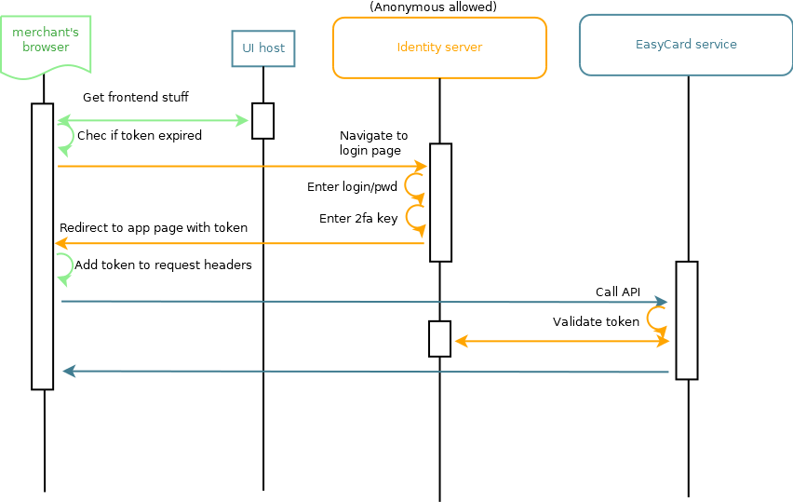

### TLS Settings for application service

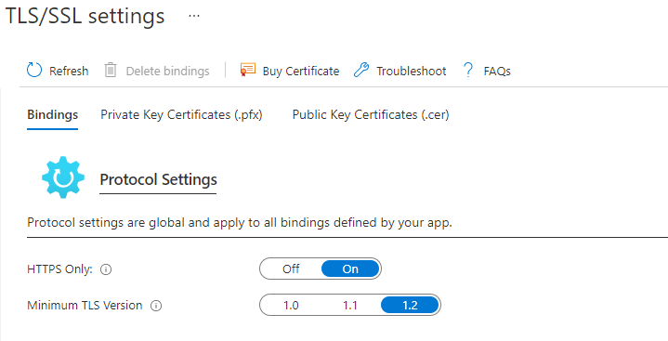

### 2FA Enabled 8.3.1a

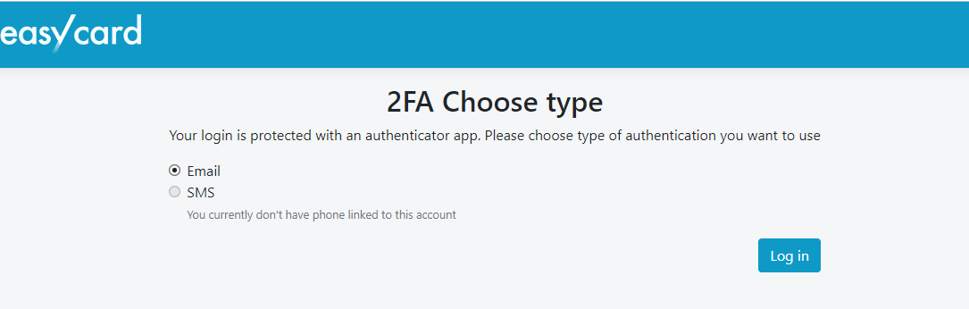

**Lock account after 5 attempts 8.1.6b**

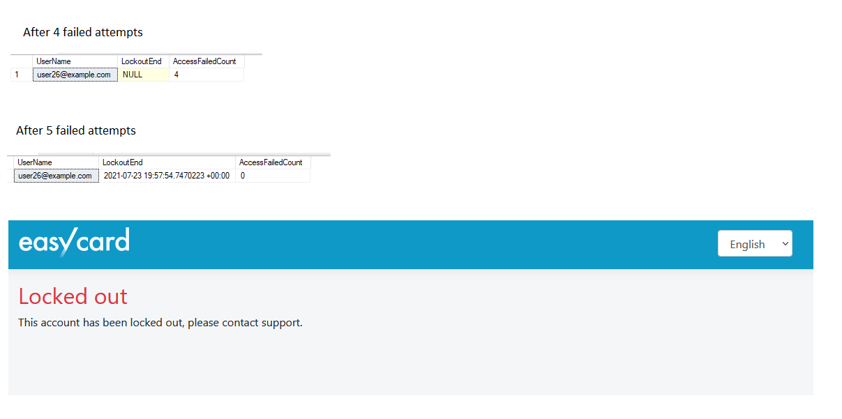

**Password oprtions 8.1.7, 8.2.3a**

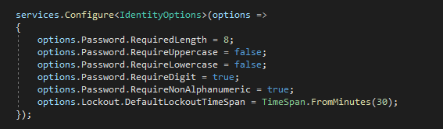

## System components and user roles samples

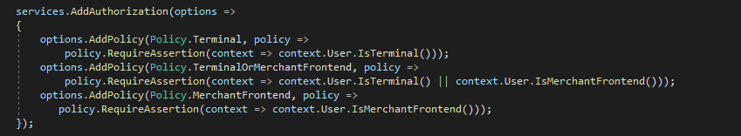

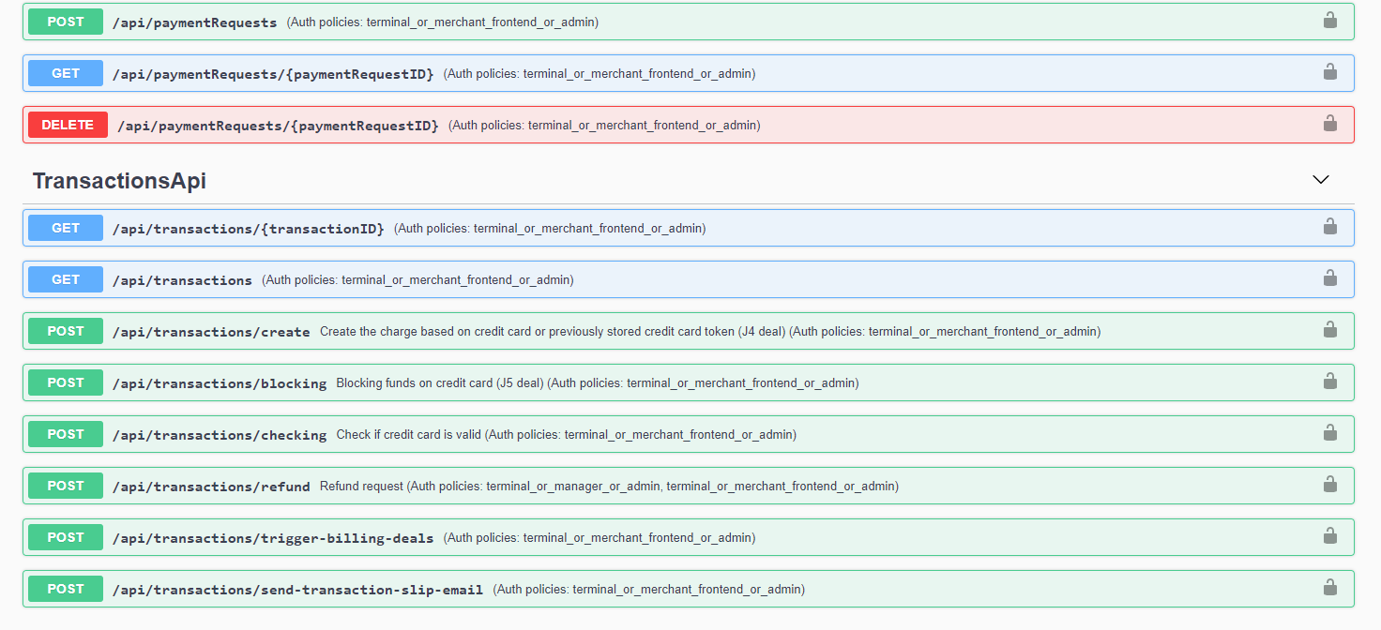

## Azure AD roles assignment sample

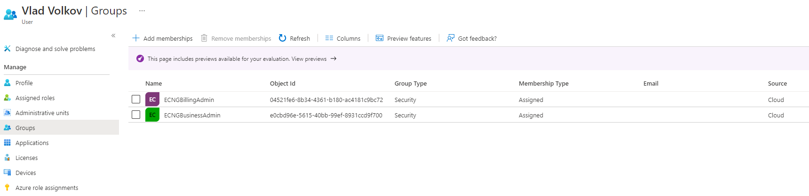

## Merchant user roles assignment sample

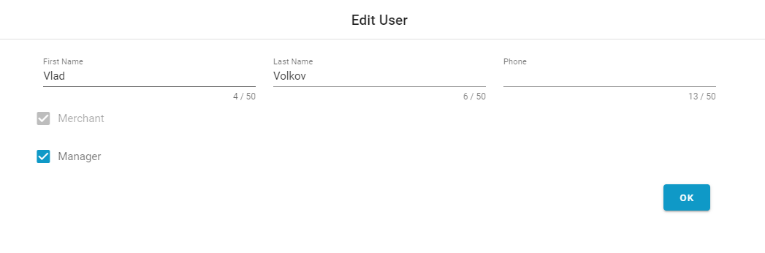

## First time login and password complexity 8.2.6, **8.2.3b**

